28-Homobrassinolide

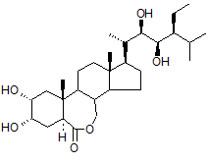

Common name | 28-Homobrassinolide
Chemical name | (5S,6R)-10-((2S,3R,4R,5S)-5-ethyl-3,4-dihydroxy-6-methylheptan-2-yl)-5,6-dihydroxy-7a,9a-dimethyltetradecahydro-1H-benzo[c]indeno[5,4-e]oxepin-3(12bH)-one
Empirical formula | C₂₉H₅₀O₆
RMM | 494.8
m.p. | 256~257°C
v.p. | 1.01E-18mmHg at 25°C
Solubility | In water 5mg/l, acetonitrile 1.3g/l, ethanol 5.2g/l, methanol 2.7g/l at 20 °C
Description | White powder
Stability | Stable in neutral and weak alkaline condition but hydrolysed in acidic conditions
Formulation | Emulsifiable concentrate, soluble liquid

28-Homobrassinolide TECHNICAL
XXX/TC/M/-

- Sampling. Take at least 100 g.

- Identity tests
2.1 HPLC. Use the HPLC method below. The relative retention time of 28-Homobrassinolidein the sample solution should not deviate by more than 1.5% from that of calibration solution.

2.2 Infrared. Prepare potassium bromide discs for the 28-Homobrassinolide technical sample and reference substance. Scan the discs from 4000-400 cm-1. The spectrum produced from the sample should not differ significantly from that of the standard.

- 28-Homobrassinolide
OUTLINE OF METHOD The derivative of 28-Homobrassinolide by Phenylboronic acid separated and determined by HPLC on ODS-C₁₈ film stainless column with UV detector at 220 nm, quantified by external standard method.

REAGENTS
Methanol: HPLC grade
Water: HPLC grade
28-Homobrassinolide reference standard of known purity: w≥ 97.0%
Phenylboronic acid:
Preparation of Phenylboronic acid solution: Weigh approximately (to the nearest 0.01g) 1500mg Phenylboronic acid into 250ml volumetric flask. Dissolve to the mark with methanol and mix thoroughly.

APPARATUS
High-performance liquid chromatography equipped with UV detector and quantitative sampling valve.
Chromatographic work station
Column stainless steel: 250mm X 4.6 mm (id), packed with ODS-C₁₈, or equivalent
Ultrasonic bath
Filter pore diameter: 0.45µm
Automatic sampler: 50µL

PROCEDURES
(a) LIQUID CHROMATOGRAPHIC CONDITIONS (typical)
Mobile phase: acetonitrile+ water = 80 + 20（v/v）
Flow rate: 1.0ml/min
Detector wavelength: 220 nm
Injection volume: 10μL
Column temperature: 25°C
Retention time:
28-Homobrassinolide: approximately 20.5min.

(b) Equilibration of the chromatographic system. Inject the calibration solution and repeat the injections until retention times and the response factors calculated from the peak areas vary by less than 1.5% for successive injections.

(c) Preparation of standard solution: prepare standard solution in duplicate. Weigh 0.015g (to the nearest 0.1mg) 28-Homobrassinolide standard into 25ml volumetric flask, dissolved by 10ml methanol. Add 10ml phenylboronic acid solution, react 30min in calorstat at 50°C. Allow the solution to cool to ambient temperature and fill to the mark with methanol. Mix thoroughly and place the flask in an ultrasonic bath for 5 min, then filter the solution through a 0.45μm filter membrane prior to analysis.
Preparation of sample solution: prepare sample solution in duplicate. Weigh 0.015g (to the nearest 0.1mg) sufficient sample to contain about 15mg 28-Homobrassinolide into 25ml volumetric flask, dissolved by 10ml methanol. Add 10ml phenylboronic acid solution, react 30min in calorstat at 50°C. Allow the solution to cool to ambient temperature and fill to the mark with methanol. Mix thoroughly and place the flask in an ultrasonic bath for 5 min, then filter the solution through a 0.45μm filter membrane prior to analysis. (Sample solutions S1 and S2)

(d)Determination: Inject in duplicate 10μL portions of each sample solution bracketing them by injections of the calibration solutions as follows: C_{A}, S₁, S₁, C_{B}, S₂, S₂, C_{A}, etc.

(e)Calculation

Content of 28-Homobrassinolide = g/kg
where:
fi=individual response factor
f= mean response factor
Hs=peak areas of 28-Homobrassinolide in the calibration solution
Hw=peak areas of 28-Homobrassinolide in the sample solution
s=mass of 28-Homobrassinolide standard (mg)
w=mass of sample taken(mg)
P=purity of 28-Homobrassinolide standard (g/kg)

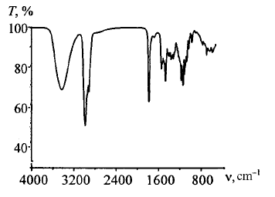
Fig 1 Infrared spectra of 28-Homobrassinolide

28-HOMOBRASSINOLIDE EMULSIFIABLE CONCENTRATE
******-
- Sampling. Take at least 1l.

- Identity tests. As for 28-Homobrassinolide technical ******

- 28-Homobrassinolide. As for 28-Homobrassinolide technical *****

28-HOMOBRASSINOLIDE soluble liquid
******-
- Sampling. Take at least 1l.

- Identity tests. As for 28-Homobrassinolide technical ******

- 28-Homobrassinolide. As for 28-Homobrassinolide technical *****

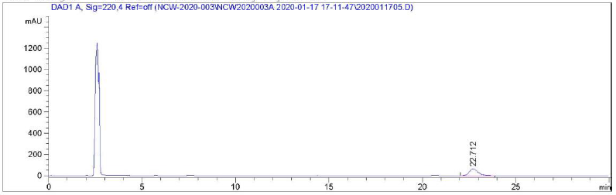
Fig 2 Chromatogram of 28-Homobrassinolide standard

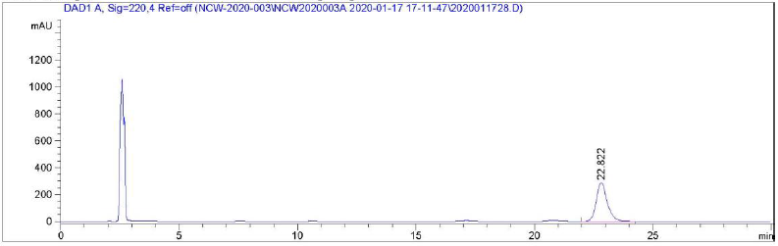
Fig 3 Chromatogram of 28-Homobrassinolide TC sample

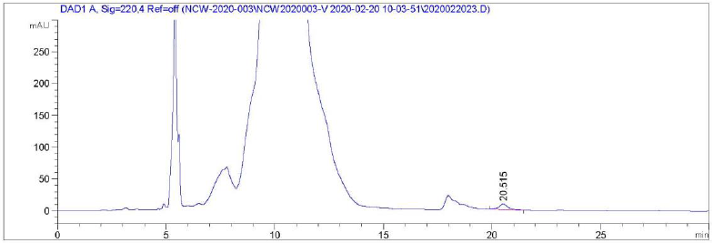
Fig 4 Chromatogram of 28-Homobrassinolide 0.01%EC sample

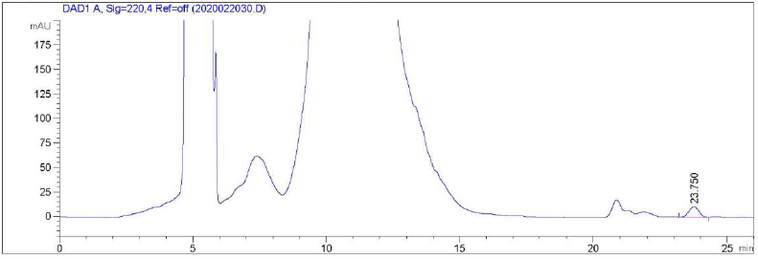
Fig 5 Chromatogram of 28-Homobrassinolide 0.01%SL sample

